**Assignment**

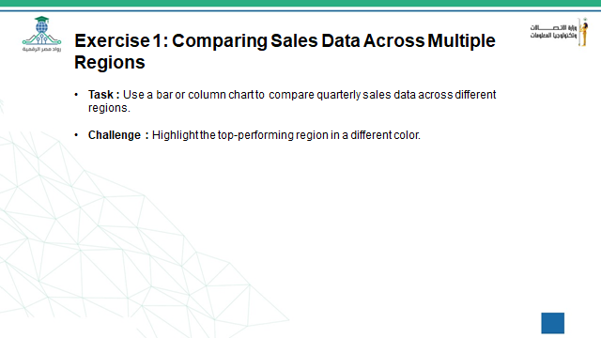

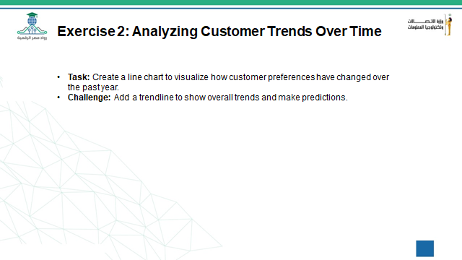

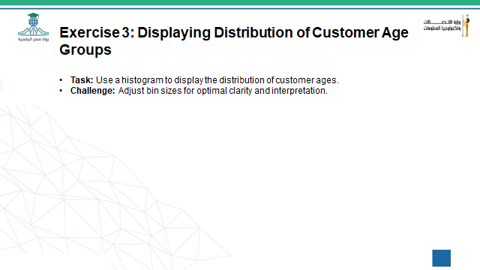

**Exercise (4)**

1. **What are the total sales for a specific category (e.g., "Electronics")?**
2. **How many transactions were above a specified amount, like $1000?**
3. **What is the average sales amount for transactions over $500?**
4. **Use a line chart to analyze sales trends over time.**
5. **Use a bar chart to compare sales across different product categories.**
6. **Which product category has the highest sales?**